DSpotTest technical specifications

- Scalability
  - Modular project structure
A modular structure is adopted in order to keep code easily localizable. A module is defined by a set of views which share functionality and make use of the components, utils and everything else that is needed to be defined inside the module. A module also defines a set of routes to navigate around its views using ReactRouter. There’s also a ‘common’ section for the code that’s shared between several modules.

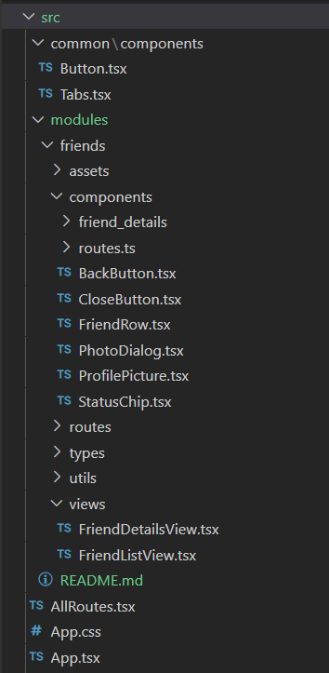

  - State Management
Application-wide state should be considered to be handled globally using tools such as Redux. State shared locally (inside a module) by several views or components should also be handled by this kind of tool using a modular approach.

  - Styleguide
    - Airbnb and javascript/typescript google styleguide
Airbnb React/JSX Style Guide standards should guide the code in addition to several considerations and modifications. Everything not covered in this standard plus considerations falls back to Google JavaScript Style Guide.

    - Additional considerations
- Directory names should use underscore_case
- Props spreading for props pass through use cases generated by the use of styled components
- no-confusing-arrow, operator-linebreak and implicit-arrow-line break rules are not considered for compatibility with prettier formatter

  - Scalability tools
    - ReactRouter
ReactRouter helps modularity structure by rendering the corresponding view components depending on the url path.

    - Redux [future work]
It’s a tool for global state management.

    - Toastify [future work]
It’s a react library which allows globally (using a wrapper) toasting notifications to the user from any context of the application. Very useful for user feedback, specially in large applications

    - WrapperLayouts [future work]
Set of components which are common to several views, so they are placed typically as a wrapper for those views. A good example of layout could be a wrapper containing a drawer and a section for rendering different views conditionally. WrapperLayouts work are typically used with Nested Routes

    - Eslint and Prettier
Eslint is set to follow the rules defined by Airbnb React/JSX Style Guide in compatibility with Prettier formatter using eslint-config-airbnb and eslint-config-prettier plugins.

- Maintainability
  - Code blocks simplicity
Code blocks, functions and components should be as small as possible as first-sight indicative of well separated responsibilities. A well distinguished block duty makes it easier to maintain code by sections and also makes it more readable.

  - Component nesting and props
Multiple levels of props nested from child to parent can make the code to be hard to track and consequently to maintain.

  - Naming convention
All names should be descriptive but not redundant. Components names and filenames should refer to the component overall functionality or propose. Ex CloseButton instead of just Close

  - Prefer pure functions
Pure functions are deterministic with respect to its arguments. Using conditions referring to global state or static variables inside functions should be avoided.

- Reliability
  - Unit/Component testing
All components that contain any functionality (besides displaying static information) should be tested individually in a unit/component test. Cypress component tests are used for that end in this project.

  - Integration testing
All views should be included in at least one integration test where its functionality and the functionality of its childs can be tested as a whole.They should be also included in a test involving navigation toward and from each one of them.

Note: In any case meaningless test should be avoided

  - Error handling and validation
For integration's sake, no variable value should be assumed, so validation is needed in order to grant the code won't crash given unexpected conditions. Probable error cases should be always handled.

- General
  - Typescript
Using typescript helps with code integrity, preventing potential error to happen in runtime “passing” them to the transpilation phase. It also makes the code more readable and type definitions enforces autocomplete intellisense features improving its scalability and maintainability.

  - Documentation and comments
General and per-module documentation should enforce code maintainability. Ambiguous / non-descriptive code should be commented

